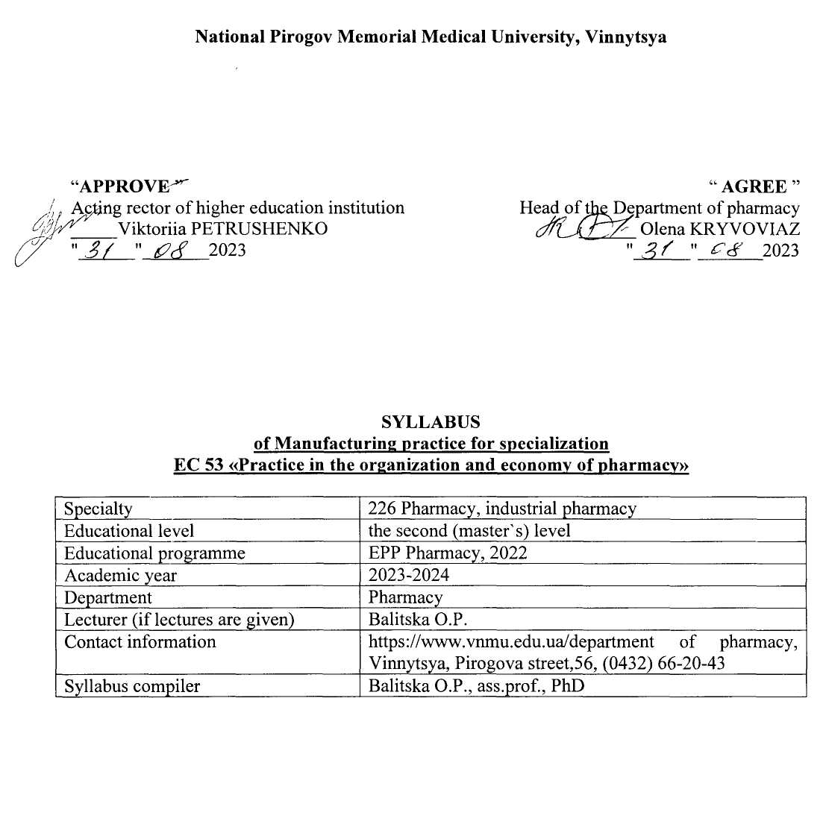

1. Status and structure of the discipline
Discipline status | Compulsory
Discipline code in EPP/ discipline place in EPP | EC 53 /discipline of professional training
Course / semester
  5rd year (ІX semester)
  135 hours / 4,5 credits ECTS
The amount of discipline ( the total number of hours / number of credits ECTS) | Practical classes - 30 hours  Independent work - 105 hours
Language of study | Ukrainian, English
Form of study | Full - time

2. Description of the discipline
Short annotation of the course, relevance. In the general system of pharmacist training, manufacturing practice by specialization "Practice on organization and economics of pharmacy" is studied in the semester - 9 (full-time).
The main task of the course organization and economics of pharmacy is to promote the formation of professional necessary knowledge, skills and abilities in accordance with the educational and qualification characteristics; provide a theoretical basis for further study of other pharmaceutical and economic disciplines of the curriculum; create a base that determines the professional competence and general erudition of pharmacists. According to the curriculum, the study of the manufacturing practice by specialization "Practice on organization and economics of pharmacy" is carried out in the 5th year of study, and includes practical classes on the organization of pharmaceutical supply and accounting system in pharmacy.
The organization of the educational process is carried out according to the credit-transfer system. The amount of student workload is described in ECTS credits - credit credits that are credited to students upon successful completion of the course.
The credit-transfer system of the educational process encourages students to study systematically during the academic year.
Types of classes according to the curriculum are practical classes, independent work of students.
Practical classes according to the method of their organization are practice-oriented, because they provide:
- checking the correctness of prescriptions written out by doctors;
- checking the correctness of the documents in accordance with the supply contract;
- implementation of reception, storage and release of medicines and medical devices;
- conducting commodity examination of medicines;
- organization and control of cash transactions and non-cash payments with suppliers and buyers of pharmaceuticals;
- keeping records of the results of pharmacies.
Prerequisites
The history of medicine and pharmacy is a discipline that studies the laws of development and the history of medical and pharmaceutical knowledge throughout the history of mankind - from ancient times to the present.
Information technology in the pharmacy is a discipline that studies the latest information technologies and modern applications in the field of pharmacy.
Drug technology – is a discipline that studies the theoretical foundations and production processes of processing drugs into drugs (medicines) by providing them with a specific dosage form based on established physical, chemical, mechanical and other for the purpose of the course and its importance for professional activities.
Management and marketing in pharmacy – is a discipline whose purpose is to provide future professionals with knowledge and skills of doing business in the market, as well as the management of pharmaceutical companies with various forms of ownership and management.
Medical and pharmaceutical commodity science – is a discipline that forms knowledge of product quality requirements and skills of commodity analysis, acceptance, storage, transportation and sale of products; improving methods of quality control of medical and pharmaceutical products.
Pharmaceutical Law studies the laws and regulations of Ukraine, which regulate pharmaceutical activities, management, accounting and tax accounting, as well as the skills to process them.
Pharmacoeconomics is an applied science, which is a methodology for comparative evaluation of medical technologies, based on a comprehensive analysis of the results of their application and economic costs.
The purpose of the course and its significance for professional activities. (The purpose of teaching the manufacturing practice by specialization "Practice on organization and economics of pharmacy" is to form in higher education a system of knowledge about the organizational and economic aspects of pharmaceutical activities in modern conditions.
The main objectives of the manufacturing practice by specialization "Practice on organization and economy of pharmacy" are as follows:
to promote the formation of professionally necessary knowledge, skills and abilities in accordance with educational and qualification characteristics; to provide a theoretical basis for further study of other pharmaceutical and economic disciplines; professional competence and general erudition of pharmacists.
According to the requirements of the educational-professional program, applicants for higher education must:
To know:
✓ principles of organization of pharmaceutical supply of the population in accordance with the requirements of Good Pharmacy Practice;
✓ requirements of international standards of pharmaceutical activity;
✓ regulations governing pharmaceutical activities;
✓ basic principles of the National Medical Policy;
✓ organizational structure of the pharmaceutical industry and the basic principles of the state regulation of pharmaceutical activity;
✓ tasks and functions of pharmacies and their structural units;
✓ rules for writing and accepting prescriptions;
✓ rules for dispensing drugs with electronic prescriptions;
✓ the procedure for dispensing drugs that are subject to reimbursement;
✓ legal and regulatory framework governing the circulation of controlled substances at the international and national levels;
✓ classification of narcotic drugs, psychotropic substances and precursors;
✓ organizational structure of the state system for quality assurance of medicines;
✓ organizational principles of pharmaceutical information at the level of health professionals and the public;
✓ the order of operation of pharmacies with inventories;
✓ organization of the system of accounting and reporting in pharmacies;
✓ the procedure for preparing management, accounting and financial statements;
✓ forms of financial reporting, their structure and purpose;
✓ features of small business reporting;
✓ the main economic indicators of the pharmacy;
✓ functions and principles of health insurance;
✓ basic principles of taxation in Ukraine;
✓ basic principles of pharmacy lending;
✓ State regulation of prices for medicines.
✓ be able to:
✓ release over-the-counter and prescription drugs;
✓ accept prescriptions from the population, analyze errors;
✓ dispense prescription drugs;
✓ dispense medicines with electronic prescriptions.
✓ to charge for various prescriptions, to determine tariffs for the manufacture of extemporaneous drugs;
✓ keep records of outpatient prescriptions;
✓ organize subject-quantitative accounting of drugs in the pharmacy;
✓ organize the acceptance of goods from suppliers;
✓ to organize incoming quality control of medicines;
✓ organize information work in the pharmacy;
✓ organize proper storage of medicines and pharmaceutical products;
✓ issue the release of goods to other departments and structural units of the pharmacy, hospital;
✓ document the receipt of goods;
✓ compile and analyze accounting entries;
✓ draw up documents on the accounting of wholesale and retail sales of goods, other costs of goods;
✓ compile the balance of the pharmacy (pharmaceutical company);
✓ apply methods of economic analysis;
✓ analyze the prescriptions and turnover of the pharmacy,
✓ calculate the standard of inventories;
✓ classify costs according to different criteria:
✓ analyze and plan to win turnover;
✓ calculate the profit and profitability of the enterprise.
According to the requirements of the standard, the discipline provides acquisition by students
competencies:
- integral:
ability to solve typical and complex specialized problems and practical problems in professional pharmaceutical activity using the provisions, theories and methods of basic, chemical, technological, biomedical and socio-economic sciences; integrate knowledge and solve complex issues, formulate judgments on insufficient or limited information; clearly and unambiguously communicate their conclusions and knowledge, reasonably substantiating them, to professional and non-professional audience.
General competencies (GC):
GC 1. Ability to act socially responsible and civic conscious.
GC 2. Ability to apply knowledge in practical situations.
GC 4. Ability to abstract thinking, analysis and synthesis, to learn and be modernly trained.
GC 6. Knowledge and understanding of the subject area and understanding of the profession.
GC 11. Ability to assess and ensure the quality of work performed.
Special (Professional, subject) competencies (PC):
PC 1. Ability to conduct sanitary and educational work among the population in order to prevent common diseases, prevention of dangerous infectious, viral and parasitic diseases, as well as to facilitate the timely detection and maintenance of adherence to treatment of these diseases in accordance with their medical and biological characteristics and microbiological features.
PC 2. Ability to provide advice on prescription and over-the-counter drugs and other products of the pharmacy range; pharmaceutical care during the selection and sale of over-the-counter drugs by assessing the risk / benefit, compatibility, indications and contraindications based on data on the health of a particular patient, taking into account biopharmaceutical, pharmacokinetic, pharmacodynamic and physicochemical characteristics of the drug and other pharmaceutical products .
PC 4. Ability to ensure the rational use of prescription and over-the-counter drugs and other pharmaceutical products in accordance with the physicochemical, pharmacological characteristics, biochemical, pathophysiological features of a particular disease and pharmacotherapeutic regimens for its treatment.
PC 7. Ability to ensure proper storage of medicines and other pharmaceutical products in accordance with their physicochemical properties and the rules of Good Storage Practice (GSP) in health care facilities.
PC 8. Ability to organize the activities of the pharmacy to provide the population, health care facilities with medicines and other goods of the pharmacy
range and implement appropriate reporting and accounting systems for management, statistical, accounting and financial) in accordance with the requirements of the National Medical Policy, Good Pharmacy Practice (GPP) and carry out commodity analysis, administrative records taking into account the organizational and legal norms of pharmaceutical legislation.
PC 9. Ability to analyze and forecast the main economic indicators of pharmacies, to calculate basic taxes and fees, to form prices for medicines and medical devices in accordance with current legislation of Ukraine.
PC 11. Ability to analyze socio-economic processes in pharmacy, forms, methods and functions of the pharmaceutical supply system and its components in world practice, indicators of need, efficiency and availability of pharmaceutical care in terms of health insurance and reimbursement of the cost of drugs.
PC 17. Ability to organize and carry out general and marketing management of assortment, commodity-innovative, pricing, sales and communication policies of pharmaceutical market entities based on the results of marketing research and taking into account market processes in national and international markets, risk management in the pharmaceutical system .
PC 19. Ability to organize and control the quality of medicines in accordance with the requirements of the current State Pharmacopoeia of Ukraine and good practices in pharmacy, determine methods of sampling for control of medicines and standardize them in accordance with current requirements, prevent the spread of counterfeit medicines.
Postrequisites This discipline will be needed in professional activities in order to skillfully apply research methods of economic processes occurring in the enterprise, skillfully perform analytical calculations to assess key indicators characterizing the activities of the pharmaceutical company, search and calculate reserves to improve production efficiency and develop effective management decision.
3. Learning outcomes.

Program learning outcomes (PLO)
PLO 1. Carry out professional activities in social interaction based on humanistic and ethical principles; identify future professional activities as socially significant for human health.
PLO 2. Apply knowledge of general and professional disciplines in professional activities.
PLO 4. Demonstrate the ability to independently search, analyze and synthesize information from various sources and use these results to solve typical and complex specialized tasks of professional activity.
PLO 6. Argue information for decision-making, be responsible for them in standard and non-standard professional situations; adhere to the principles of deontology and ethics in professional activities.
PLO 7. Perform professional activities using creative methods and approaches.
PLO 9. Carry out professional activities using information technology, "Information databases", navigation systems, Internet resources, software and other information and communication technologies.
PLO 10. Adhere to the norms of communication in professional interaction with colleagues, management, consumers, work effectively in a team.
PLO 12. Analyze the information obtained as a result of scientific research, summarize, systematize and use it in professional activities.
PLO 13. Carry out sanitary-educational work in professional activity in case of outbreaks of infectious, viral and parasitic diseases.
PLO 19. To forecast and determine the impact of environmental factors on the quality of medicines and consumer characteristics of other products of the pharmacy range during their storage.
PLO 20. Carry out a set of organizational and managerial measures to provide the population and health care facilities with medicines and other products of the pharmacy range. Carry out all types of accounting in pharmacies, administrative records, processes of commodity analysis.
PLO 21. Calculate the main economic indicators of pharmacies, as well as taxes and fees. To form all types of prices (wholesale, purchase and retail) for medicines and other products of the pharmacy range.
PLO 23. Take into account data on socio-economic processes in society for the pharmaceutical supply of the population, determine the effectiveness and availability of pharmaceutical care in terms of health insurance and reimbursement of the cost of drugs.
PLO 24. To plan and implement professional activity on the basis of normative legal acts of Ukraine and recommendations of good pharmaceutical practices.

4. Content and logistic of the discipline
Module 1 "Organization of pharmaceutical supply. Accounting systems in the pharmacy. | 5rd year (IX semester)  135 hours / 4,5 credits | Lectures № -  Practical classes № 15  Topics for self- study № 11

Module 1 «Organization of pharmaceutical providing. Accounting systems in pharmacy».
1. The organizational structure of pharmacy. Pharmaceutical information.
2. Organization of drugs sale by the prescriptions.
3. Social meaning of free and preferential dispensing of drugs and medicinal goods.
4. Features of dispensing drugs to outpatients drugs that are subject to reimbursement.
5. Organization of compounding-production department work. Rules for the manufacture of drugs in a pharmacy.
6. Quality control of drugs in pharmaceutical enterprises.
7. Organization of the supply department work. The study of administrative drug activity.
8. Organization of OTC sales drugs.
9. Quality control of medicines in pharmacies. Organization of insidepharmacy quality control of medicinal products. Automation of commodity stocks.
10. Organization of primary accounting in pharmacies. Account structure. The method of double entry of business transactions. Chart of accounts and the relationship with financial statements.
11. The structure of external financial reporting of pharmacies.
12. Organization of goods movement in the pharmacy.
13. Organization of other assets in the pharmacy.
14. Organization of accounting salary and wages.
15. Incentive and compensation payments of pharmacy employees.
16. Rules of pricing for finished pharmaceuticals and medical products. State regulation of pricing of medicines, medical devices and related products.
17. Organization of cash flow accounting of pharmacy enterprises.
18. Accounting of monetary transactions on the current account.
19. Inventory of goods.
20. Inventory of other types of goods and material assets of the pharmacy.
21. Financial results of the enterprise. Analysis of financial results and profitability.

Practical classes provide a theoretical justification of the main issues of the topic and the acquisition of the following practical skills:
1) work with regulatory documents
2) analyze the financial condition of the pharmacy on the basis of financial statements
3) carry out incoming quality control of drugs
The student's independent work provides preparation for practical classes and intermediate tests,
study of topics for independent extracurricular work, writing essays, preparation of presentations, tables. The control of mastering the topics of independent extracurricular work is carried out at the intermediate control classes and the final control of the discipline.
Individual work includes the study of scientific literature, preparation of reviews on the topics provided for presentation at the meetings of the student scientific circle, the implementation of scientific and practical researches, participation in specialized competitions, scientific and practical conferences and organization of students' research works.
Thematic plans of lectures, calendar plans of practical classes, thematic plan of independent extracurricular work, volume and directions of individual work are published on the website of the department.
The route for obtaining materials: Department of pharmacy / for students / Full-time education / (specialty) pharmacy, industrial pharmacy /5 course / Educational materials / or through the link https://www.vnmu.edu.ua/ department of pharmacy #. Access to the materials is carried out through the student's corporate account s000XXX@vnmu.edu.ua.
5. Forms and methods of monitoring academic performance
Current control in practical studies | Methods: oral or written survey, testing, electronic survey, solving situational problems, conducting laboratory studies, interpreting them and evaluating their results (drawing up a protocol in a workbook)
Control of mastering the thematic section of the discipline at intermediate control lessons | Methods: oral or written survey, electronic testing, situational problem solving, control of practical skills
Final semester control (credit) at the end of the ___ semester  (If provided by the curriculum) | According to the Regulation of the Academic process in VNMU named after M.I. Pirogov (link https://www.vnmu.edu.ua/General information)
Final control of the discipline - _______________ (exam or grading test) | Methods: pre-examination testing, oral questioning (according to the Regulation of the Academic process in VNMU named after M.I. Pirogov (link https://www.vnmu.edu.ua/General information)
Learning success diagnostic tools | Theoretical questions, tests, clinically-oriented situational tasks, practical tasks, practical skills demonstration

6. Assessment criteria
Knowledge assessment is carried out in accordance with the Regulations of the Academic process in VNMU named after M.I. Pirogov ( link https://www.vnmu.edu.ua/General information)

Continuous assessment | On a four point system of traditional assessments: 5 «excellent», 4 «good»,3 «satisfactory», 2 «unsatisfactory»
Midpoint separation assessment | On a four-point system of traditional assessments
Control of practical skills | According to the four-point system of traditional assessments
Pass-fail exam | On a 200-point scale (the arithmetic average grade for the semester is converted into points)  Credited: 120 to 200 points  Not credited: less than 120 points (See Grading Scale)
Final control of the discipline | Sum of points for pre-examination testing (12-20 points) and oral questioning (38-60 points) (for disciplines included in Step 1,2)  Exam grade:  71-80 points - "excellent"  61-70 points - "good"  50-60 points - "satisfactory"  Less than 50 points - "unsatisfactory" / did not pass
Discipline assessments: | Current academic assessment - from 72 to 120 points (conversion of the average traditional assessment of practical class on a 120-point scale): 60% of the grade for the discipline  Final control - from 50 to 80 points: 40% of the grade for the discipline  Individual work - from 1 to 12 points  From 122 to 200 points in total.

Discipline Score Scale: National and ECTS
The sum of grades for all types of educational activities | Score ECTS | Score on a national scale
The sum of grades for all types of educational activities | Score ECTS | For exam, course project (work), practicе | for credit test
180-200 | А | excellent | credited
170-179,9 | В | good | credited
160-169,9 | С | good | credited
141-159,9 | D | satisfactory | credited
122-140,99 | Е | satisfactory | -
120-140,99 | Е | - | credited
119-61 | FX | unsatisfactory with the possibility of reassembly | is not credited with the possibility of reassembling
1-60 | F | unsatisfactory with a mandatory reexamination of discipline | is not credited with mandatory reexamination of discipline

7. Policy of discipline / course
The student has the right to receive high-quality educational services, access to contemporary scientific and educational information, qualified advisory assistance during the study of discipline and mastering practical skills. The policy of the department during the providing of educational services is a student-centered, based on normative documents of the Ministry of Education and the Ministry of Health of Ukraine, the Statute of the University and the Procedure for the Providing of Educational Services regulated by the main principles of the organization of the educational process in VNMU named after M.I.Pirogov and the principles of academic integrity ( link https://www.vnmu.edu.ua/General information).
Adherence to the rules of VNMU, safety techniques in practical classes.
Safety instruction is given at the first practical lesson by the teacher. The briefing is registered in the Safety Briefing Journal. Applicant for higher education who has not been instructed is not allowed to practical class.
In the case of the announcement of the signal "Air alarm" or other warning signals, the teacher stops the class, informs the students of higher education about the need to proceed to the shelter of civil defense and stay there until the signal is canceled. The teacher informs the students of higher education about further actions after canceling the signal: to continue the class or to recommend to complete the material independently with a further survey at the next class (order № 505 dated 08.30.2023).

Requirements for preparation for practical classes. Student should be present at the practical lesson on time, theoretically prepared according to the topic. Applicant for higher education should come to class on time, without lateness. Applicant for higher education who is late is not allowed to study and must rework it in the prescribed manner.
In practical classes, the student must be dressed in a work uniform. Applicants for higher education who do not have a work uniform are not allowed to study.
The student must follow the rules of safety in practical classes and during the stay in the department.
When discussing theoretical issues, students should demonstrate tolerance, courtesy and respect for their colleagues and the teacher; when performing practical tasks, the workplace should be kept in order and cleaned after the practical work.
Usage of mobile phones and other electronic devices. The use of mobile phones and other electronic devices in the classroom is allowed only on the instructions of the teacher.
Academic integrity. When studying the discipline, the student must be guided by the Code of Academic Integrity and Corporate Ethics of VNMU named after M.I. Pirogov (link : https://www.vnmu.edu.ua/General information)/ Code of Academic Integrity). In case of violation of the norms of academic integrity during the current and final controls student receives a grade of "2" and must work it out to his teacher in the prescribed manner within two weeks after receiving an unsatisfactory assessment).
Academic integrity. During the study of the discipline the Applicants for higher education must be guided by the Code of Academic Integrity of VNMU named after MI Pirogov. In case of violation 

