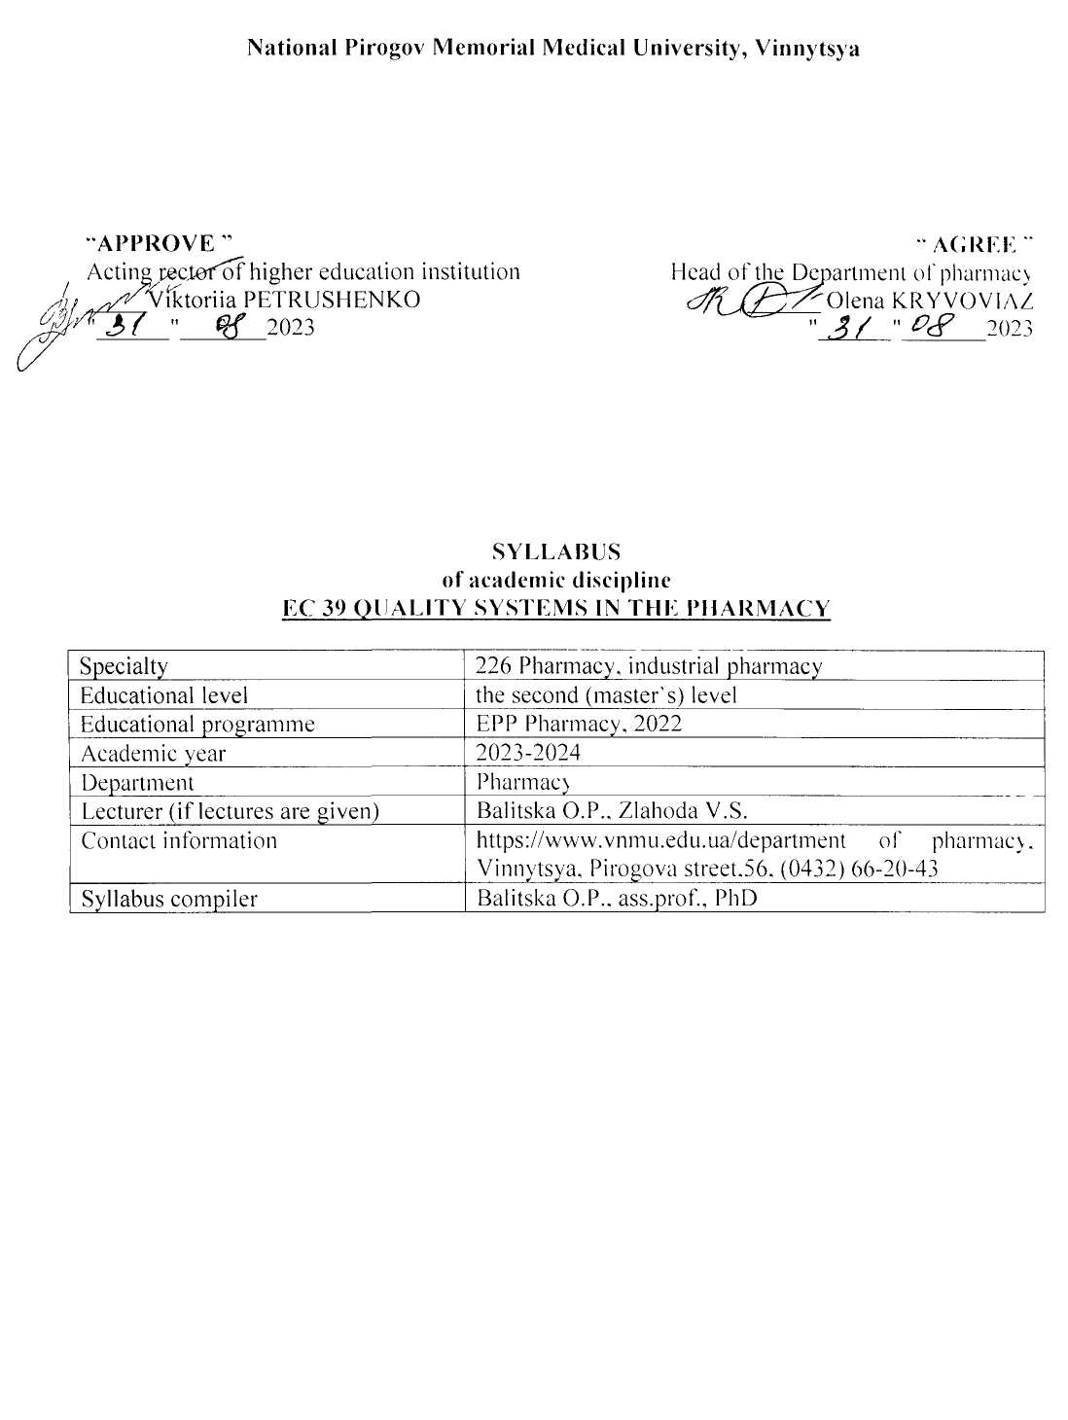

- Status and structure of the discipline
Discipline status | Compulsory
Discipline code in EPP/ discipline place in EPP | EC 39 / discipline  of professional training
Course / semester | 5th year (IX semester)
The amount of discipline ( the total number of hours / number of credits ECTS) | 90 hours / 3 credits ECTS
Number of content modules | 1 module
The structure of the discipline | Lectures - 18hours  Practical classes 32 hours  Independent work 40 hours
Language of study | English
Form of study | Full - time

2. Description of the discipline
Short annotation of the course, relevance In the general system of pharmacist training, the discipline "Quality Systems in the Pharmacy" is a profile discipline in the preparation of pharmacists, which equips students with knowledge, practical skills and abilities necessary to perform professional commodity functions. The main tasks of studying the quality system in pharmacy are the introduction of the national quality system in pharmaceutical enterprises; organization of economic activity in the production, wholesale and retail trade of medicines; creation of sanitary and anti-epidemic measures in pharmaceutical enterprises; quality control between consumers of pharmaceutical goods and services and performers; analysis of the market quality system in procurement; compliance with national legislation in pharmaceutical companies.
According to the curriculum, this discipline is studied in the 5th year of study and includes lectures and practical classes. Lectures on the quality system in pharmacy cover problematic issues of the quality system in pharmaceutical companies.
Practical classes according to the method of their organization are practice-oriented, because they provide:
- keep records of wholesale and retail sales of pharmaceutical products in the documents of primary accounting;
- keep records of the cost of inventory in the relevant documentation;
- fill in the registers and organize efficient document flow.
Assimilation of the topic is controlled in practical classes in accordance with specific objectives, assimilation of sections - in practical final classes. The following means of diagnosing the level of preparation of students are used: tests, solving situational problems, filling out workbooks, evaluation of legal documents.
The final control of mastering the course of the discipline "Quality Systems in Pharmacy" is carried out after its completion. Assessment of student achievement in the discipline is a rating and is set on a multi-point scale and is determined by the ECTS system and the scale adopted in Ukraine.
Prerequisites
Management and marketing in the pharmacy - studies the features of providing future professionals with knowledge and skills of doing business in a market environment, as well as the management of pharmaceutical companies with different forms of ownership and management.
Pharmaceutical Law - studies the laws and regulations of Ukraine, which regulate pharmaceutical activities, management, accounting and tax accounting, as well as the skills to process them.
The purpose of the course and its significance for professional activities.
The purpose of the course: is the introduction of a national quality system in pharmaceutical companies; organization of economic activity in the production, wholesale and retail trade of medicines; creation of sanitary and anti-epidemic measures in pharmaceutical enterprises; quality control between consumers of pharmaceutical goods and services and performers; analysis of the market quality system in procurement; compliance with national legislation in pharmaceutical companies.
Postrequisites
Organization and economy of pharmacy – is a specialized pharmaceutical discipline that studies the organizational, managerial and economic activities of the subjects of circulation of drugs, economic relations between them and the external environment. The purpose of the Organization and economy of pharmacy is to gain knowledge and practical skills in the field of planning, organization, analysis, control, accounting and other activities of the subjects of circulation of medicines to provide quality pharmaceutical care.
Pharmaceutical and medical commodity science is a discipline that studies the consumer properties of pharmaceutical and medical products, their range, classification and coding, standardization, commodity operations related to factors that affect the quality, organization of storage, conditions of transportation of goods.
Pharmacoeconomics – is an applied science that is a methodology for comparative evaluation of medical technologies (methods of prevention, diagnosis and treatment, including the use of drugs), based on a comprehensive analysis of the results of their application and economic costs
- Learning outcomes.
The course "Quality Systems in the Pharmacy" provides the acquisition of higher education by such competencies as:
Integral (IC): the ability to solve typical and complex specialized problems and practical problems in professional pharmaceutical activities using the provisions, theories and methods of basic, chemical, technological, biomedical and socio-economic sciences; integrate knowledge and solve complex issues, formulate judgments on insufficient or limited information; clearly and unambiguously communicate their conclusions and knowledge, reasonably substantiating them, to professional and non-professional audience.
General competencies (GC):
GC 1. Ability to act socially responsible and civic conscious
GC 2. Ability to apply knowledge in practical situations.
GC 4. Ability to abstract thinking, analysis and synthesis, to learn and be modernly trained.
GC 6. Knowledge and understanding of the subject area and understanding of professional activity.
GC 11. Ability to assess and ensure the quality of work performed.
GC 12. Ability to conduct research at the appropriate level.
Special (Professional, subject) competencies (PC):
PC 7. Ability to ensure proper storage of medicines and other pharmaceutical products in accordance with their physicochemical properties and the rules of Good Storage Practice (GSP) in health care facilities.
PC 8. Ability to organize the activities of pharmacies to provide the population, health care facilities with medicines and other products of the pharmacy range and implement appropriate reporting and accounting systems (management, statistical, accounting and financial) in accordance with the requirements of the National Medical Policy, Appropriate Pharmacy practice (GPP) and to carry out commodity analysis, administrative record keeping taking into account organizational and legal norms of the pharmaceutical legislation.
PC 12. Ability to use in professional activities knowledge of regulations, legislation of Ukraine and recommendations of good pharmaceutical practices.
PC 14. Ability to organize and carry out the production activities of pharmacies for the manufacture of drugs in various dosage forms on prescriptions and orders of medical institutions, including technology justification and selection of auxiliary materials in accordance with the rules of Good Pharmacy Practice (GPP).
PC 18. Ability to develop and implement a quality management system for pharmaceutical companies in accordance with the requirements of current Standards, perform quality audits and risk management for the quality of pharmaceutical products.
PC 19. Ability to organize and control the quality of medicines in accordance with the requirements of the current State Pharmacopoeia of Ukraine and good practices in pharmacy, determine methods of sampling for control of medicines and standardize them in accordance with current requirements, prevent the spread of counterfeit medicines.
PC 20. Ability to develop methods for quality control of medicines, including active pharmaceutical ingredients, medicinal plant raw materials and excipients using physical, chemical, physicochemical, biological, microbiological, pharmacotechnological and pharmacoorganoleptic control methods.

Program learning outcomes (PLO):
PLO 2. Apply knowledge of general and professional disciplines in professional activities.
PLO 4. Demonstrate the ability to independently search, analyze and synthesize information from various sources and use these results to solve typical and complex specialized tasks of professional activity.
PLO 6. Argue information for decision-making, be responsible for them in standard non-standard professional situations; adhere to the principles of deontology and ethics in professional activities.
PLO 10. Adhere to the norms of communication in professional interaction with colleagues, management, consumers, work effectively in a team.
PLO 19. Predict and determine the impact of environmental factors on the quality of medicines and consumer characteristics of other products of the pharmacy range during their storage.
PLO 20. Carry out a set of organizational and managerial measures to provide the population and health care facilities with medicines and other products of the pharmacy range. Carry out all types of accounting in pharmacies, administrative records, processes of commodity analysis.
PLO 24. To plan and implement professional activity on the basis of normative legal acts of Ukraine and recommendations of good pharmaceutical practices.
PLO 30. Ensure quality control of medicines and document its results. Manage quality risks at all stages of the life cycle of medicines.

- Content and logistic of the discipline
Module 1 "Quality systems in pharmacy" | IX semester  90 hours / 3 credits | Lectures № 9  Practical classes № 13  Topics for self- study № 13
The course includes 13 topics, which are divided into 2 content modules.

Module 1 "Quality systems in pharmacy"
Content module 1. The quality assurance system of medicines in Ukraine
- Basics of the national quality system in pharmaceutical companies
- Requirements for carrying out economic activities of the manufacturing medicines
- Requirements for carrying out economic activities of the wholesale realisation of medicines
- Requirements for carrying out economic activities of the retail realisation of medicines
- Basic principles of state control in pharmacy.
Content module 2. Activities of state regulatory organs in the field of quality assurance of medicines
- State mechanisms of control of hygienic and anti-epidemic measures in pharmaceutical enterprises
- Quality system between consumers of pharmaceutical commodities, services and
manufacturers, salespersons
- Market quality system of the buying and economical competition of the pharmaceutical companies
- State quality regulation of the tax legislation in pharmaceutical enterprises
- Inspection of pharmaceutical enterprises by law enforcement agencies
- State policy of quality control of medicines, medical equipment and wares medical setting. Market control.
- Requirements for pharmaceutical staff and their qualifications.
- Responsibility in pharmacy

The topics of the lecture course reveal the problematic issues of the relevant sections of the discipline. Methodology of lectures: lectures are not held in classrooms; materials are posted on the information resources of the department.
Practical classes provide a theoretical justification of the main issues of the topic and the acquisition of the following practical skills:
1) Determine the functioning of the quality system in pharmaceutical companies, taking into account the requirements of international and national standards.
2) Design the necessary list of documents for regulation of processes of quality system in pharmacy.
3) Develop, organize and improve the quality system in pharmaceutical companies.

The student's independent work provides preparation for practical classes and intermediate tests,
study of topics for independent extracurricular work, writing essays, preparation of presentations, tables. The control of mastering the topics of independent extracurricular work is carried out at the intermediate control classes and the final control of the discipline.
Individual work includes the study of scientific literature, preparation of reviews on the topics provided for presentation at the meetings of the student scientific circle, the implementation of scientific and practical researches, participation in specialized competitions, scientific and practical conferences and organization of students' research works.
Thematic plans of lectures, calendar plans of practical classes, thematic plan of independent extracurricular work, volume and directions of individual work are published on the website of the department.
The route for obtaining materials: Department of Pharmacy / for students / Full-time education / Pharmacy, industrial pharmacy/5 course/Educational materials/or through the link https://www.vnmu.edu.ua/ department of pharmacy #. Access to the materials is carried out through the student's corporate account s000XXX@vnmu.edu.ua.
5. Forms and methods of monitoring academic performance
Current control in practical studies | Methods: oral or written survey, testing, electronic survey, solving situational problems, conducting laboratory studies, interpreting them and evaluating their results (drawing up a protocol in a workbook)
Control of mastering the thematic section of the discipline at intermediate control lessons | Methods: oral or written survey, electronic testing, situational problem solving, control of practical skills
Final semester control (credit) at the end of the VII semester  (If provided by the curriculum) | According to the Regulation of the Academic process in VNMU named after M.I. Pirogov (link https://www.vnmu.edu.ua/General information)
Final control of the discipline - Own business. Pharmacy (exam or grading test) | Methods: pre-examination testing, oral questioning (according to the Regulation of the Academic process in VNMU named after M.I. Pirogov (link https://www.vnmu.edu.ua/General information)
Learning success diagnostic tools | Theoretical questions, tests, clinically-oriented situational tasks, practical tasks, practical skills demonstration
6. Assessment criteria
Knowledge assessment is carried out in accordance with the Regulations of the Academic process in VNMU named after M.I. Pirogov ( link https://www.vnmu.edu.ua/General information)

Continuous assessment | On a four point system of traditional assessments: 5 «excellent», 4 «good»,3 «satisfactory», 2 «unsatisfactory»
Midpoint separation assessment | On a four-point system of traditional assessments
Control of practical skills | According to the four-point system of traditional assessments
Pass-fail exam | On a 200-point scale (the arithmetic average grade for the semester is converted into points)  Credited: 120 to 200 points  Not credited: less than 120 points (See Grading Scale)
Final control of the discipline | Sum of points for pre-examination testing (12-20 points) and oral questioning (38-60 points) (for disciplines included in Step 1,2)  Exam grade:  71-80 points - "excellent"  61-70 points - "good"  50-60 points - "satisfactory"  Less than 50 points - "unsatisfactory" / did not pass
Discipline assessments: | Current academic assessment - from 72 to 120 points (conversion of the average traditional assessment of practical class on a 120-point scale): 60% of the grade for the discipline  Final control - from 50 to 80 points: 40% of the grade for the discipline  Individual work - from 1 to 12 points  From 122 to 200 points in total.

Discipline Score Scale: National and ECTS
The sum of grades for all types of educational activities | Score ECTS | Score on a national scale
The sum of grades for all types of educational activities | Score ECTS | For exam, course project (work), practicе | for credit test
180-200 | А | excellent | credited
170-179,9 | В | good | credited
160-169,9 | С | good | credited
141-159,9 | D | satisfactory | credited
122-140,99 | Е | satisfactory | -
0-121,99 | FX | unsatisfactory with the possibility of reassembly | is not credited with the possibility of reassembling
 | F | unsatisfactory with a mandatory reexamination of discipline | is not credited with mandatory reexamination of discipline

7. Policy of discipline / course
The student has the right to receive high-quality educational services, access to contemporary scientific and educational information, qualified advisory assistance during the study of discipline and mastering practical skills. The policy of the department during the providing of educational services is a student-centered, based on normative documents of the Ministry of Education and the Ministry of Health of Ukraine, the Statute of the University and the Procedure for the Providing of Educational Services regulated by the main principles of the organization of the educational process in VNMU named after M.I.Pirogov and the principles of academic integrity ( link https://www.vnmu.edu.ua/General information).
Adherence to the rules of VNMU, safety techniques in practical classes.
Safety instruction is given at the first practical lesson by the teacher. The briefing is registered in the Safety Briefing Journal. Applicant for higher education who has not been instructed is not allowed to practical class.
In the case of the announcement of the signal «Air alarm» or other warning signals, the teacher stops the class, informs the students of higher education about the need to proceed to the shelter of civil defense and stay there until the signal is canceled. The teacher informs the students of higher education about further actions after canceling the signal: to continue the class or to recommend to complete the material independently with a further survey at the next class (order No. 505 dated 08/30/2023).
Requirements for preparation for practical classes. Student should be present at the practical lesson on time, theoretically prepared according to the topic. Applicant for higher education should come to class on time, without lateness. Applicant for higher education who is late is not allowed to study and must rework it in the prescribed manner.
In practical classes, the student must be dressed in a work uniform. Applicants for higher education who do not have a work uniform are not allowed to study.
The student must follow the rules of safety in practical classes and during the stay in the department.
When discussing theoretical issues, students should demonstrate tolerance, courtesy and respect for their colleagues and the teacher; when performing practical tasks, the workplace should be kept in order and cleaned after the practical work.
Usage of mobile phones and other electronic devices. The use of mobile phones and other electronic devices in the classroom is allowed only on the instructions of the teacher.
Academic integrity. When studying the discipline, the student must be guided by the Code of Academic Integrity and Corporate Ethics of VNMU named after M.I. Pirogov (link : https://www.vnmu.edu.ua/General information)/ Code of Academic Integrity). In case of violation of the norms of academic integrity during the current and final controls student receives a grade of "2" and must work it out to his teacher in the prescribed manner within two weeks after receiving an unsatisfactory assessment).
Academic integrity. During the study of the discipline the Applicants for higher education must be guided by the Code of Academic Integrity of VNMU named after MI Pirogov. In case of violation of the norms of academic integrity during the current and final controls, the Applicants for higher education receives a grade of "2" and must work it in the prescribed manner for two weeks.
Missed classes. Missed classes are working out in the manner prescribed by Regulations of the Academic process in VNMU named after M.I. Pirogov (link https://www.vnmu.edu.ua/General information) at the time of work out schedule (published on the website of the department https://www.vnmu.edu.ua/ department of pharmacy #) to the teacher on duty.


